 | Wind Sensor Instructions

Date: | 22/10/21 | Version: | 1.0 | By: | Matt Little

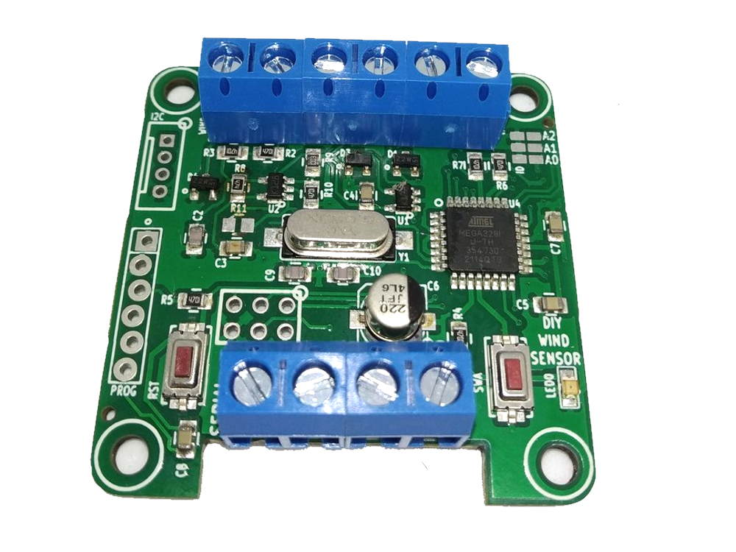  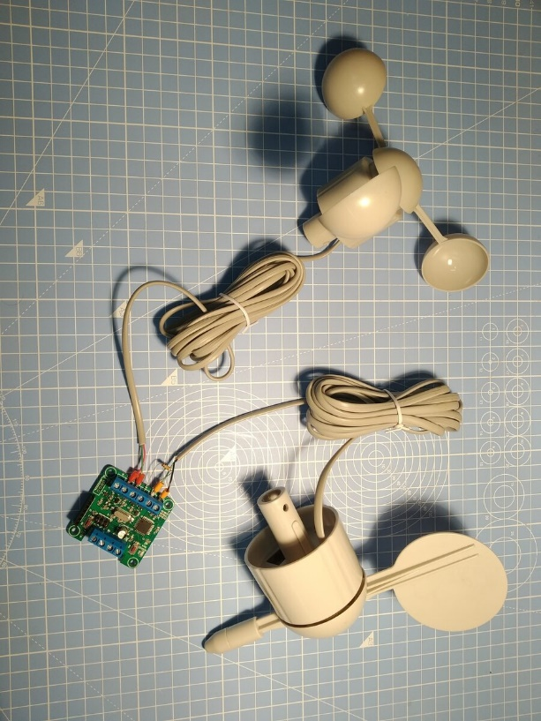 | This connects to various anemometers and wind vanes and provides a serial interface for averaged data from the pulses.  The problem with measuring wind anemometers and wind vane is that they constantly need to be checked. You need to always know when pulses have come in and which direction the wind vane is facing. This requires a bit of microcontroller time and processing.  This unit is designed to solve that. Wire up your vane and anemometer. Power the unit up. Then it will save the averaged data for you. You can then get hold of the data through serial requests and process as you need.  This unit can be ‘trained’ for your Wind Vane and the pulses converted into a real wind speed with a “Y=mX +c) conversion. The conversion values can be adjusted for your anemometer.  All the firmware, unit operation and serial commands can be found here:  https://github.com/curiouselectric/WindSensor

Parts included:
5 x 2 way Screw Terminals
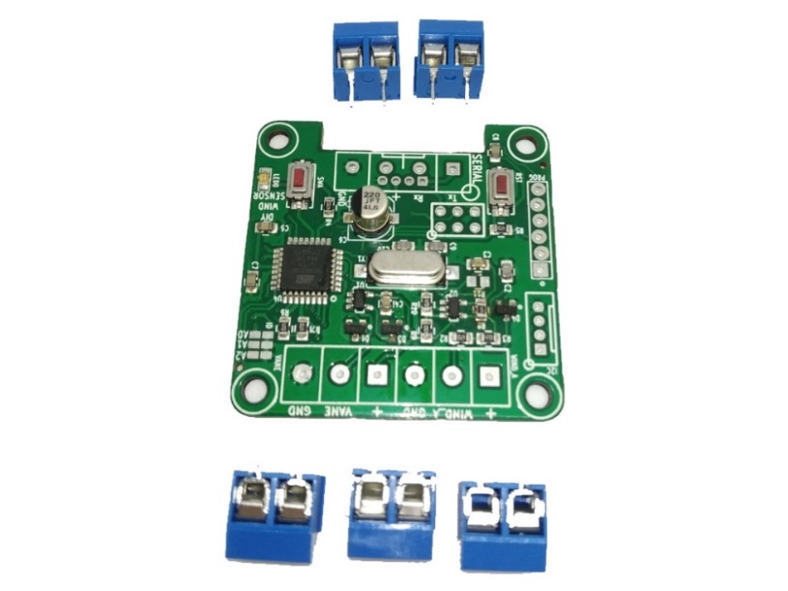
PCB with SMD components

Parts list:
Item | Ref | Quantity
2 way screw terminals |  | 5
PCB with all SMD components soldered |  | 1

Tools required:

 | 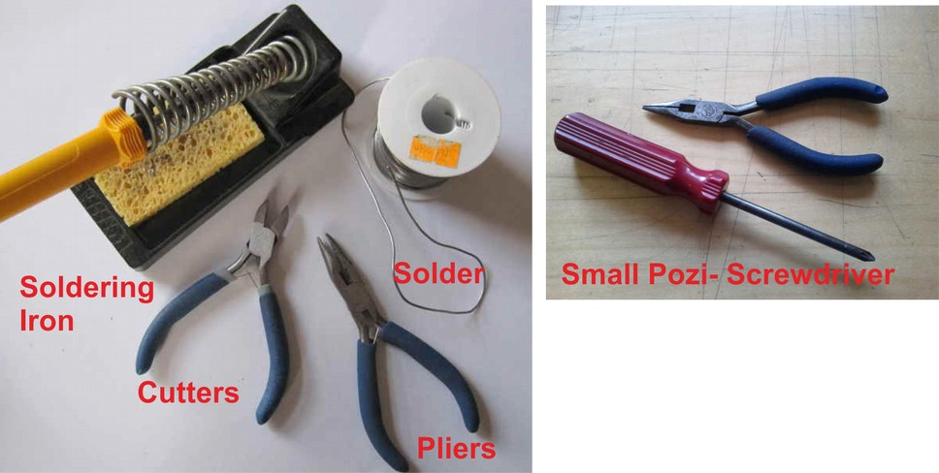
Long-nosed
Pliers
Soldering Iron |  | Posi-drive  Screwdriver
Solder
Side cutters
Additional Items
- USB to 6 way ‘FTDI’ style serial converter:
  - Search for “FT232RL USB to TTL MiniUSB Port FTDI Serial Adapter Module for Arduino 5V 3.3V” on eBay
  - Or this FTDI one: https://ftdichip.com/products/ttl-232r-3v3/
  - You can also use an Arduino as a USB to serial converter.
- To update/change code: Computer with Arduino IDE and additional libraries installed. (see software section for more details)
Instructions:
Step: 1 | Solder Screw Terminals
There are 5 2 way screw terminals to solder.  Link two of them to make a 4 way connector and solder into the ‘serial’ connection.  Link three of them and solder into the WIND_A connections.  That’s all the soldering done! |  | 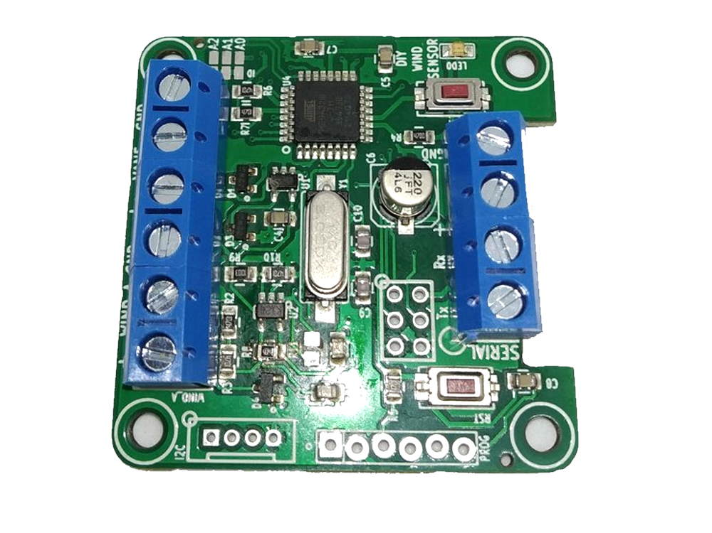

Step: 2 | Set ID
This step is not usually required. You can set the ID of the unit by connecting some pads with a solder blob.  Solder according to this table. “Solder” means connect the two pads, “NC” means no connection. The default is 0. |  | 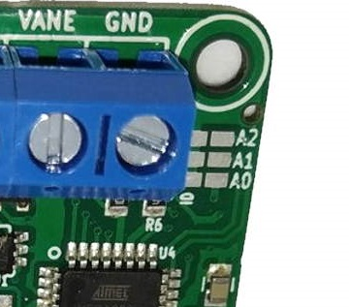
  A0 | A1 | A2 | ID
  NC | NC | NC | 0
  Solder | NC | NC | 1
  NC | Solder | NC | 2
  Solder | Solder | NC | 3
  NC | NC | Solder | 4
  Solder | NC | Solder | 5
  NC | Solder | Solder | 6
  Solder | Solder | Solder | 7

Step: 3 | Wire up Anemometer
Wiring for this depends upon the type of anemometer:  For switched pulse anemometers: connect the switch to 0V and to PULSE input, as there is a pull-up resistor.  For NPN output anemometers:  The +V will supply the Vcc to your anemometer. Typically, this is 3.3V or 5V.  Wire this to the +ve of your anemometer. 0V is ground.  Wire the NPN pulse output to PULSE.  For Hall-Effect anemometers:  Connect the output to the 0V and the PULSE input. |  | 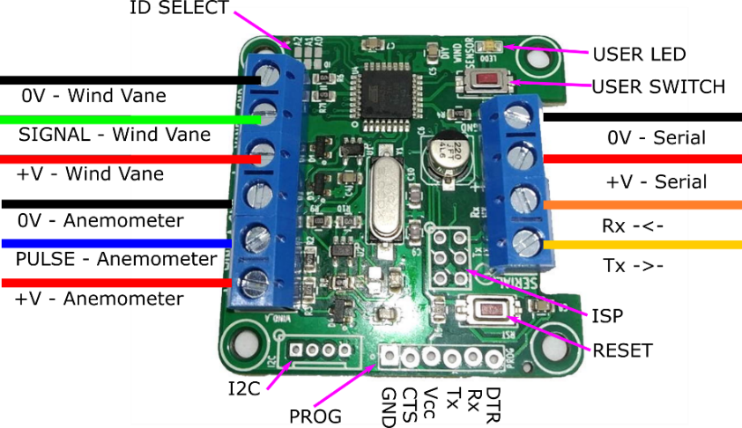

Step: 4 | Wire up Wind Vane
The wind vane wiring will also be different depending upon the type of vane.  For a resistive switched output, then you will need to use a 10k or 100k pull up resistor. Wire the vane output to 0V and SIGNAL. Wire a pull-up resistor to SIGNAL and +5V.  For potentiometer output sensors wire the 0V to one side of the variable resistor and the +5V for the other side of the variable resistor. The wire the wiper to SIGNAL.  Basically, you are trying to make a variable voltage input for the SIGNAL input. |  | 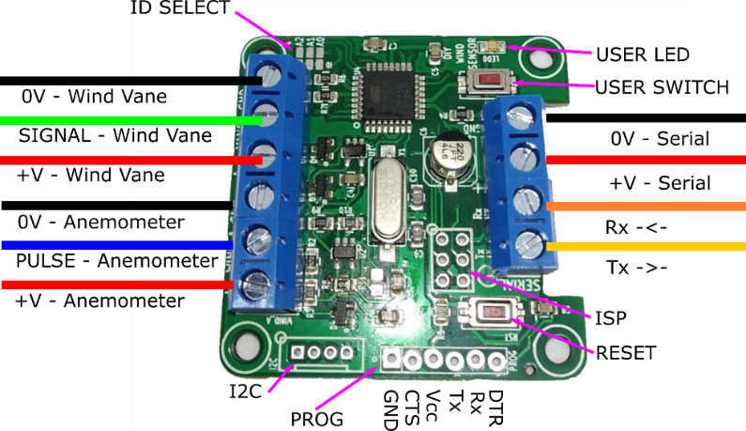

Step: 5 | PCB is finished!
  Have a nice cup of tea. |  | That didn’t take long, did it?

Step: 6 | Connect to Arduino or USB-Serial Converter
There is one main serial connector which has 0V, +V for the serial and also Rx and Tx.  Upload a blank or ‘bare minimum’ sketch to an Arduino.  You can wire your Arduino Tx to Rx and Rx to Tx.  If you monitor the serial port at 9600 baud then you can send and receive responses.  Follow the github examples and information for the most up to date information regarding the serial data and the functionality of the unit. |  | 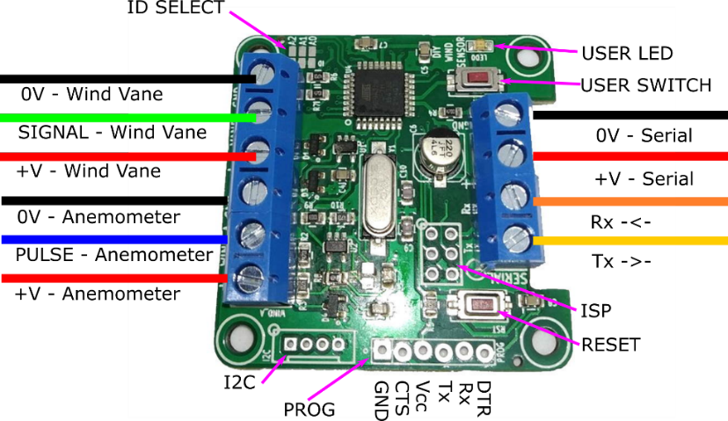

Step: 7 | Send Serial Commands
There are many serial commands that the unit can respond to.
Please see:
https://github.com/curiouselectric/WindSensor
For the most recent information. This is kept online, so it can be easily updated.

Step: 8 | Write your own code
Everyone’s application is different, so this is where things get fun for your application!

You need to think about what you would like from the unit.

I have set up units that send out data at regular 1min outputs with a wireless transmitter. This used broadcast mode.

I have also set up units that record the data to an SD card by using request mode.

Upload Firmware
This is not needed for standard use of the unit.

This can be where the fun begins! You can alter the code and improve it as you need.

This project has software stored on GITHUB software repository here:

https://github.com/curiouselectric/WindSensor

Please follow the readme in this repository for the most up to date instructions.

Contact details:
This kit has been designed and produced by:

The Curious Electric Company
hello@curiouselectric.co.uk
www.curiouselectric.co.uk
4 Cragland Park, Great Urswick, Ulverston, LA12 0TX

We would like you to be happy with this kit. If you are not happy for any reason, then please contact us and we will help to sort it out.

Please email hello@curiouselectric.co.uk with any questions or comments.
Please tweet us at @curiouselectric

If any parts are missing from your kit, then please email hello@curiouselectric.co.uk with details, including when and where the kit was purchased.

More technical information can be found via www.curiouselectric.co.uk

Circuit Schematic:
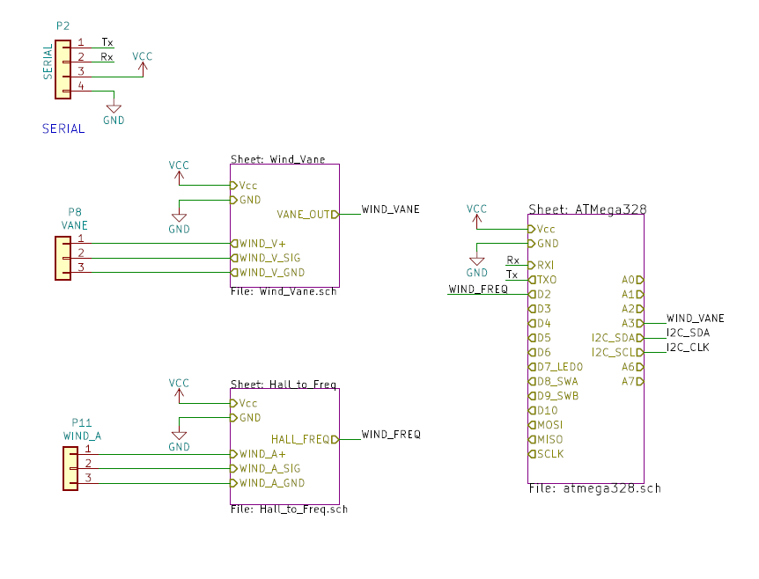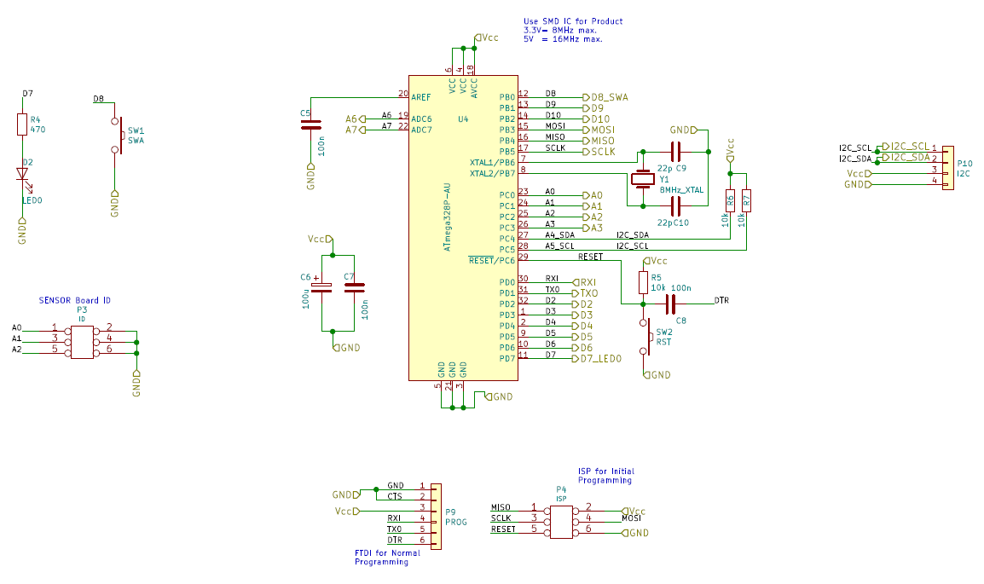

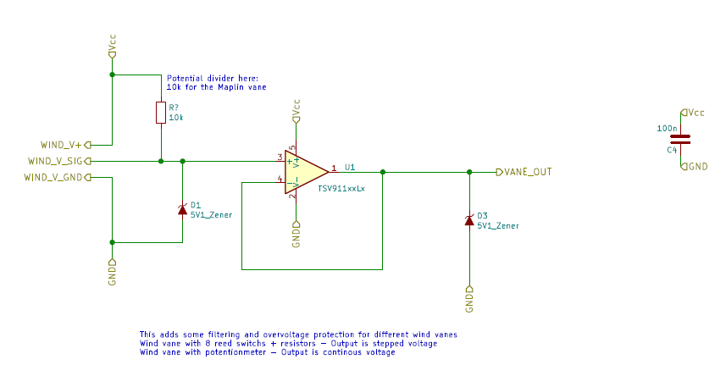

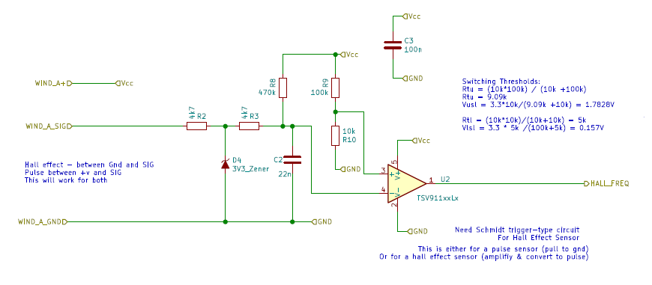

PCB Design:

